Bluetooth Beacon for indoor positioning

# Beacon positioning principle

Ibeacon is a low-energy Bluetooth technology that works similarly to the previous Bluetooth technology.

Beacon transmits signals, Bluetooth devices receive positioning, and feedback signals. And Beacon's broadcast has the ability to spread. When the user enters, exits, or wanders in the area, it can calculate the distance between the user and the Beacon (which can be calculated by RSSI). It can be known that if there are three Beacon devices, the user can be located.

# Algorithm to calculate the position - Trilateration

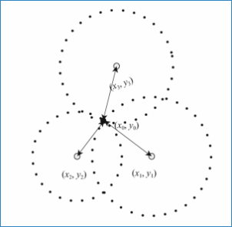

Consider such situation

1. we know the position p1 (x1,y1) p2(x2,y2) p3(x3,y3). We don’t know the position p4(x4,y4)
2. we know the unknow point’s distance between those three points L1 L2 L3

Then we can calculate the unknow point in following method

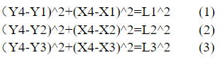

By using formula 1 – formula 3



By using formula 1 – formula 2



Let

 



Then we got (x4, y4)



# Bluetooth Beacon Deployment Solution

1) Bluetooth Beacon ground clearance: 3m

Height H: Generally between 2.5 ~ 3m. If the site installation location is high, you need to consider increasing the attenuation budget. Or use ground or wall deployment to ensure the height is within 3m.

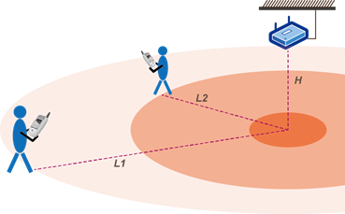

2) Bluetooth Beacon horizontal spacing: 4-8 m

One-dimensional positioning scenario: suitable for aisles with high isolation. In theory, only one column of Beacon with a spacing of 4-8m needs to be deployed in sequence.

General positioning scenario (open area): Bluetooth Beacon is deployed in a triangle uniformly, and requires 3 or more Bluetooth Beacons. The distance between each other is 4-8m.

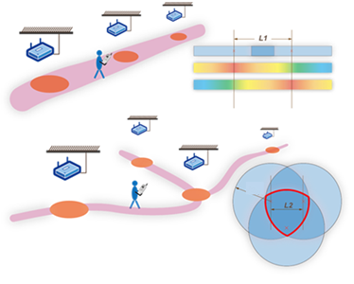

# Deployment scenarios for different scenarios

Here red points are wrong

|  |  |
| --- | --- |
| Left and right sides are deployed separately | Keep away from corners and obstacles |
| Triangular deployment | Evenly deployed |